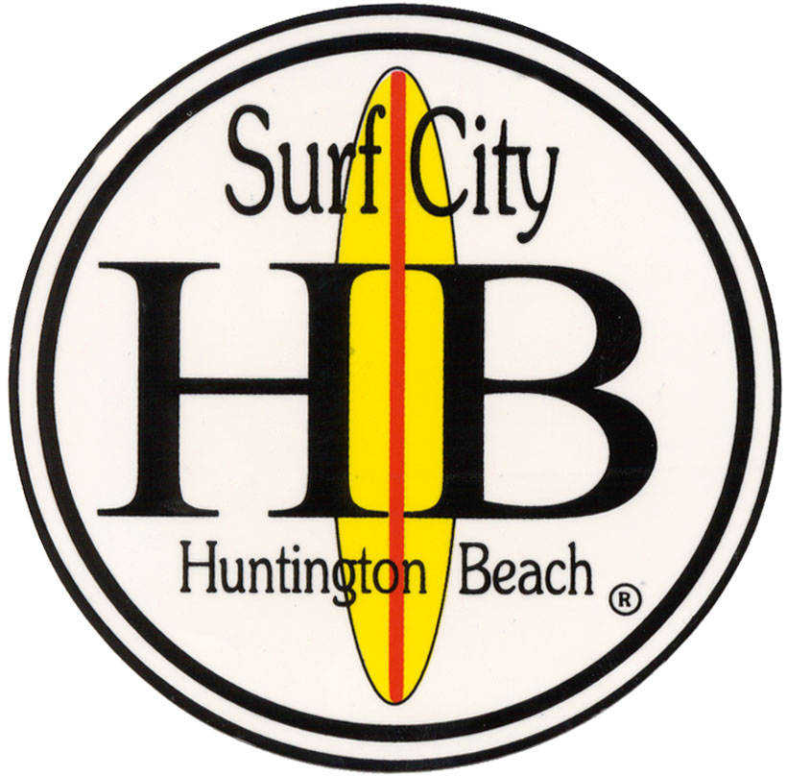
INSURANCE AND INDEMNIFICATION WAIVER

MODIFICATION REQUEST

1. Requested by:
2. Date:
3. Name of contractor/permittee:
4. Description of work to be performed:
5. Value and length of contract:
6. Waiver/modification request:
7. Reason for request and why it should be granted:
8. Identify the risks to the City in approving this waiver/modification:

Department Head Signature |  | Date:

APPROVALS

Approvals must be obtained in the order listed on this form. Two approvals are required
for a request to be granted. Approval from the City Administrator’s Office is only required if
Risk Management and the City Attorney’s Office disagree.

1. Risk Management
◻ Approved | ◻ Denied
 |  | Signature |  | Date

2. City Attorney’s Office
◻ Approved | ◻ Denied
 |  | Signature |  | Date

3. City Manager’s Office
◻ Approved | ◻ Denied
 |  | Signature |  | Date

If approved, the completed waiver/modification request is to be submitted to the
City Attorney’s Office along with the contract for approval. Once the contract has been approved,
this form is to be filed with the Risk Management Division of Human Resources

